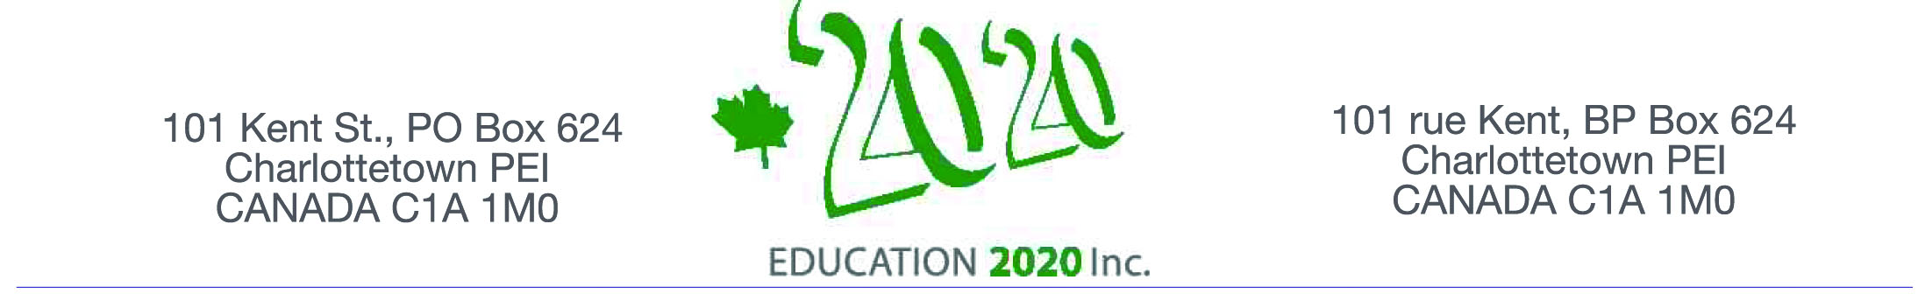

Excellence in Education Award – 2015

BACKGROUND

Our future as individuals and as communities depends to a large degree on the quality of our education. Providing a quality education should be the focus of every government, supporting a quality education the objective of every teacher and school, and gaining a quality education a major focus of every citizen.

Thanks to the generosity of an Island family, Education 20/20 Inc. has established an awards program as a mechanism to call attention of the public to important characteristics of effective schools and to provide recognition to schools for their efforts to implement them. The focus of the award is on engagement for, as the National Parent Teacher Association points out, “when families, schools, and communities work together student achievement improves, teacher morale rises and communication increases”. Study after study show the dramatic impact parental involvement makes to a child's success in school. In fact, engaging families in their children’s education improves school achievement, attendance, behaviour and graduation rates. The focus of the award will be on the daily operation of the school and on those items over which the school has substantial control.

ELEMENTS OF ENGAGEMENT

Education 20/20 supports a broad engagement across the institution including:
- Student to student based on respect, cultural competency, caring, courtesy, tact, honour, cooperation and collaboration.

- School environment that is welcoming and one that is safe and physically and emotionally comfortable, and is based on the assumptions of fairness, respect, trust, care, optimism and intentionality; a school where levels of learning are obvious and pathways well defined, where learning cuts across and beyond courses and invites students to discuss “big questions” that matter beyond the classroom and; teachers who are on the leading edge of current teaching practices and technology and work together to help students reach their objectives.

- Instruction that ensures a solid foundation and encourages critical inquiry, writing, research, collaborative learning and other skills that develop students' intellectual and practical skills; allows students to engage actively in learning and helps students make meaning of the information for application in the real world. Some examples would include collaborative projects, i.e. learning to work and solve real problems in groups, by sharpening their own understand through listening seriously to insights of others especially those from different backgrounds and cultures. Students could also be encouraged to record example of their best work through a portfolio or video and discuss their learning with other classmates and teachers.

- School Community Partnerships that emphasize experiential learning with community partners. This involves direct experience with issues, creating opportunities to learn, analyze information; being a participant in community setting also reinforces the idea of good citizenship, i.e. giving back to the community. Other examples of student/community partnership may include fundraising for various community projects and involvement in diverse community service.

- Parent involvement in their children’s education strengthens the parent teacher partnerships in the challenge of helping children reach their potential and, like any partnership, communication is key. Partnership activities will likely include parent teacher discussions, newsletters and participation in both school and community events,

DOCUMENTATION

Each nomination should include:
- Nominations close on April 25, 2015
- A brief description about what the school is trying to achieve and how engagement supports their objectives - perhaps something already distributed to parents
- Not more than one page outlining engagement activities for each element
- A list of supporting documents available in print or electronic form
- Supporting documentation including examples, newsletters, and photos

NOMINATION PROCESS

Education 20/20 called for nominations, nominations are welcomed from any interested person with the actual selection being made by a nomination committee based on documentation received.

Education 20/20 Inc.
101 Kent St., PO Box 624 / 101, rue Kent, B.P. 624
Charlottetown, PEI / Charlottetown (Î.-P.-É.) C1A 1M0 Canada
Tel./Tél. : 902-892-2060
Email/Courriel : pei@education2020.ca
URL : www.education2020.ca

